Buoy Observations Activity
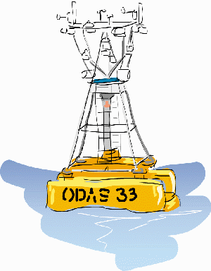

Real time weather and ocean data is available through the data portal. Every hour, the buoys record conditions in their locations throughout the ocean. Cell phone technology and satellites transmit this information to scientists, the internet and this monitor. Be a scientist and record the data!
Directions:
- Go online to the data portal to access buoy data.
- Select a buoy dot and click on it to get the information.
- Data will appear on the screen that can be copied into the tables.

ACTIVITY 1
Test and Compare: Record measurements from a near-shore buoy and an offshore buoy, then compare the data being collected by scientists.
- Record the GPS location, air temperature, water temperature, salinity and wind speed in the data table below at two different locations under the column names “Nearshore Buoy” and “Offshore buoy”.

Measurement | Nearshore Buoy | Offshore Buoy
GPS Location
Air Temperature (F)
Surface Water Temperature (F)
Surface Salinity (psu)
Wind Speed (mph)

Questions:
- Does the data differ between the nearshore and offshore buoys? Why would this be?

- Would you expect differences in buoy data from other parts of the world?

- Why is it important to know these measurements? Who can use them and who is affected (think of people and places near the water)?

ACTIVITY 2

Explore other buoys in surrounding states or countries
- Access a region or regions real time data portal (retrievable from www.ioos.noaa.gov).
- Select five different buoys in different regions and click the icon to view their data.
- Record the location, date, time, air temperature (F), water temperature (F), wind speed (mph), wind gust (mph) and wave height in the data table below.
- Plot your data as a bar graph below for each variable.

Date:
Time:
Location | AIR TEMP | WATER TEMP | WIND SPEED | WIND GUST | WAVE HEIGHT

Plot the data you collected in the graphs below at each location.

Key

